

2 Minute Form
Trip Name: Ponui Circumnavigation
Check-in Name and Phone:
Date: Branch:
Leaders
Cell Phone Number
VHF Call Sign &/or Vessel Name
Vehicle make, model, registration, colour
General Plan
Note: If plan changes, you must notify your Check-in person.
Latest Time Off the Water |  |  |  |  | TMP/AMP used²⁰
Tide/ Forecast Lake Level | Low |  |  | High | Other
Communications Carried²¹
Communications | We will be communicating as a group on VHF Channel _
Equipment Carried
Trip Report
(Use other side if more space required)

Activity |  |  | Ponui Circumnavigation |  |  |  | Centre | Auckland |  | Location |  |  |  |  | Hauraki Gulf |  | Difficulty¹ |  |  |  |  |  | Intermediate
Activity Description |  |  | Meet at Kawakawa Bay boat ramp. Note that there are two boat ramps – the one at Kawakawa Bay itself is inaccessible at low tide, another slightly further along the coast which has an all-tide boat ramp. Meet at the latter. Paddle around Ponui and return. |  |  |  |  |  |  |  |  |  | Leader qualification req.² |  |  |  |  | Trip Leader
Get in Location |  |  | Kawakawa Bay |  |  |  |  |  |  |  | Chart/ Map no.⁴ |  |  |  | 5324 |  | Distance |  |  |  |  |  | 32km
Get out Location |  |  | Kawakawa Bay |  |  |  |  |  |  |  | Coastguard Channel |  |  |  | 82 & 16 |  | Nowcasting |  |  |  |  |  | 21
Emergency get out ⁵ |  |  | Beaches and coastlines of the islands. |  |  |  |  |  |  |  | Emergency / Coastguard Station |  |  |  | Auckland |  | Phone |  |  |  |  |  | *500  09 303 4303
 |  |  |  |  |  |  |  |  |  |  | Drinking Water⁶ |  |  | Kawakawa only |  | Toilets⁷ |  |  |  |  |  | Kawakawa only
Emergency Response |  |  | Refer Emergency Response Booklet |  |  |  |  |  |  |  |  |  |  |  |  | Parking⁸ |  |  |  |  |  | Kawakawa Bay
Specific Equipment Required⁹ |  |  | Helmets recommended for rock gardening |  |  |  |  |  |  |  | Working Communications equipment in this area¹⁰ |  |  | Cell phone  Sat phone |  |  |  |  |  |  |  |  |  |  | PLB  VHF
Other resources  and notes¹¹ |  |  | Ponui Island is private property, and I understand that it is OK to land as long as you don’t make a nuisance of yourself. |  |  |  |  |  |  |  | Weather Parameters¹² |  |  | 20 knots, no more than 1m swell or surf
Previous incidents¹³
Safety Management¹⁴
Hazard |  | Significant? |  |  | Management Strategy¹⁵ |  |  |  |  |  | Hazard | Significant? |  |  | Management Strategy¹⁵
Cold Water |  | Yes |  |  | Carry spare dry clothes and shelter |  |  |  |  |  | Deep Water | Yes |  |  | Correctly fit PFDs
Medical Conditions |  | Yes |  |  | - Leader has first aid qualification  - Ask customers about medical conditions |  |  |  |  |  | Bad Weather | Yes |  |  | Understand weather forecasts.  Have back up plans or pull out if necessary
Capsizing |  | Yes |  |  | - Correctly fit PFDs  - Skills at performing rescues. |  |  |  |  |  | Heat / Sun | Yes |  |  | - Protective Clothing (worn)  - Sun Screen  - Plenty of drinks  - Sunglasses
Panic |  | Yes |  |  | Ensure conditions match level of skills |  |  |  |  |  | Obstacles | Ye s |  |  | Awareness of reefs, navigational hazards, nets
Head injury |  | Yes |  |  | Wear helmets when rock gardening if appropriate |  |  |  |  |  | Other Vessels | Yes |  |  | - Understand the “rules of the sea”  - “Be seen” – Have two of the following; flag, brightly coloured kayak, brightly coloured Pfd or hat. At night: an all round white light & a powerful torch.
Written up by: | Larraine Williams |  |  | Approved By: |  | Russell Williams |  |  | Signed: | RW |  | Date: |  |  | 21 May 2014 |  |  |  | Review in: |  | 12 months from date of approval
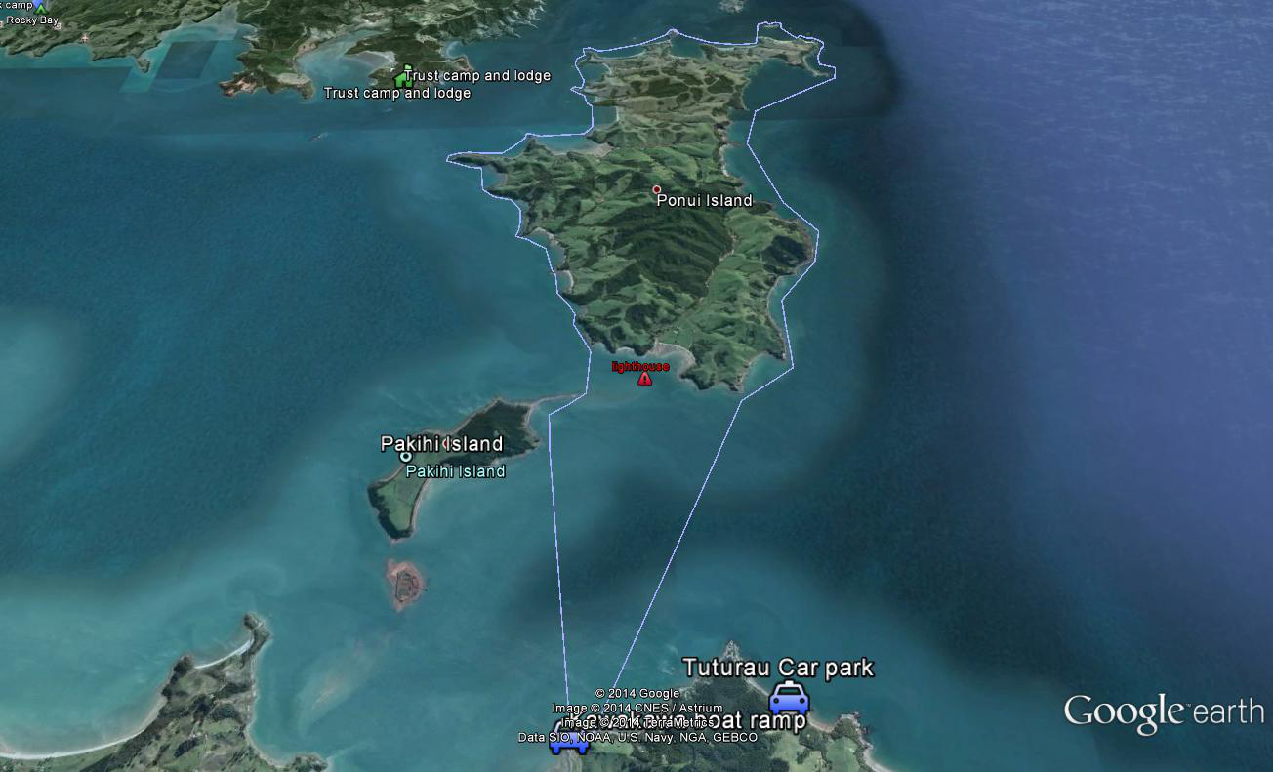

Activity Equipment Check list
Equipment List
- Helmet (rivers & surf) Group Gear
❑ Beanie / hat  Split paddles
❑ Thermals  Repair kit
❑ Paddle Jacket  Fire lighting
❑ PFD  Cooker/thermos
❑ Spray deck  Spare thermals
❑ Booties  Tow system
❑ Water & food  1st Aid Kit
❑ Kayak & paddle  Flares
Group - Oceans & Lakes  Compass
❑ Pumps & Paddle Floats  Charts / Maps
Group - River  GPS (optional)
❑ Throw ropes  Knife (cut rope)
❑ Pin kit & saw  Emergency Shelter

In case of emergency: Dial 111, Mayday :VHF Channel 16

Kayaking Check list

❑ Trip plan
❑ Latest weather forecast
❑ Conditions match skills?
❑ Hyperthermia (hot) &
Hypothermia (cold)
❑ On & off water safety
❑ Environmental concerns
❑ Emergency Procedures include emergency get out.
❑ Working communication devices
e.g. VHF radio, mobile phones, PLB
❑ Specific safety issues for this trip
❑ Participant list
❑ Any medical conditions
❑ All participants keen to proceed?

❑ Trip Plan/ 2-minute form lodged with Ops. Manager

Appropriate wind conditions to run trips:
Novice - no significant surf or swell, wind under 15knots
Intermediate- surf or ocean swells less than 1.5 meter or wind under 25 knots.
Advanced- any condition that is suitable to the trips aims

At conclusion of trip or activity:
Contact Ops Manager
Group Debrief.

Ops Manager Ph:
__________________ Mobile
__________________ Work
__________________ Home

Activity Document Cover Sheet

Activity: Intermediate trip – Kawakawa circumnavigate Ponui
Date of Activity: 21 Apr 2014

Activity reports. Is all relevant information present:
– Approved Management Plan (TMP/AMP)/ 2 minute form
– Course Participant Sheet/ Club Trip Participant Sheet
(Remove the sheet not required.)
– Weather forecast
– Activity Check List
– Trip report (May be on the 2 minute form)
– Accident / incident reports
Ops Manager Signature:
Date:

